OptiCrop: Smart Agricultural Production Optimization Engine

Project Description:
OptiCrop is an AI-powered Smart Crop Recommendation System designed to assist farmers in selecting the most suitable crops based on soil nutrients, weather conditions, temperature, humidity, pH value, and seasonal factors. The platform provides intelligent crop recommendations, soil health analysis, weather forecasting, and fertilizer suggestions to improve agricultural productivity and decision-making.
Utilizing Machine Learning algorithms and agricultural datasets, OptiCrop analyzes user inputs and generates accurate crop recommendations. Built using Python, Flask, HTML, CSS, JavaScript, and MySQL, the system provides a user-friendly interface and reliable predictions. With secure data handling and efficient processing, OptiCrop empowers farmers to optimize crop selection and maximize yield.

Scenarios
Scenario 1: A farmer enters soil nutrient values (Nitrogen, Phosphorus, Potassium), pH level, temperature, humidity, and rainfall data. The system analyzes the inputs and recommends the most suitable crop along with expected productivity insights.
Scenario 2: A farmer wants to evaluate soil health before cultivation. The Soil Analysis Module assesses nutrient levels and provides recommendations for improving soil fertility and crop growth.
Scenario 3: A farmer checks upcoming weather conditions through the Weather Forecast Module. Based on rainfall and temperature predictions, the system suggests appropriate crops and fertilizer plans to reduce agricultural risk.
Scenario 4: A farmer receives fertilizer recommendations based on soil nutrient deficiencies. The system suggests the required fertilizer type and quantity to enhance soil quality and improve crop yield.
Scenario 5: Agricultural officers and researchers use the platform to analyze farming conditions across different regions and recommend suitable crops for sustainable agriculture.

Technical Architecture:

Description: CaptionAI utilizes a modular three-tier architecture to deliver rapid, AI-driven content generation. The frontend provides a responsive user interface built with HTML and CSS while the Flask-based backend orchestrates data validation and prompt construction.
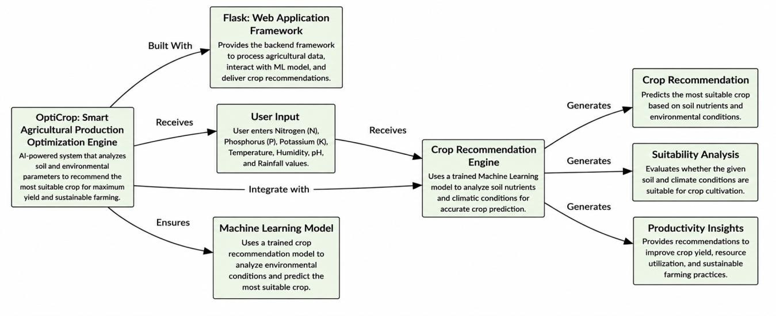

(Note: If you are using database in your project definitely you need to add ER Diagram along with description)
You can format it exactly like the blue-colored list in your sample as follows:

Pre-requisites:
- Flask Framework Knowledge: Flask Documentation
- Groq API Familiarity: Groq API Documentation
- HTML, CSS, and JavaScript Skills: W3Schools HTML/CSS/JavaScript Tutorials
- Python Programming Proficiency: Python Documentation
- Version Control with Git: Git Documentation
- Development Environment Setup: Flask Installation Guide
- Ngrok for Public Deployment: Ngrok Documentation

Below is a complete Project Workflow customized for your project AI Social Media Content Generator using Flask and Groq API.

Project Workflow
Milestone 1: Project Planning and System Design
Activity 1.1: Problem Analysis and Requirement Gathering
Identify the challenges faced by content creators in generating engaging social media content. Gather functional and non-functional requirements for the AI-powered content generation system.

Activity 1.2: Groq API Configuration and AI Model Selection
Generate and securely configure the Groq API key using environment variables. Research and select a suitable Groq Large Language Model (LLM) for generating captions, hashtags, and call-to-action (CTA) suggestions.

Activity 1.3: System Architecture Design
Design the overall architecture of the application, defining the interaction between the frontend

(HTML, CSS, JavaScript), Flask backend, Groq API, and the generated outputs.

Activity 1.4: Development Environment Setup
Install and configure the required tools and libraries, including Python, Flask, Groq SDK, HTML, CSS, JavaScript, and other project dependencies.

Milestone 2: Backend and AI Integration Activity 2.1: Flask Backend Development
Develop the Flask backend to handle user requests, process input data, manage routing, and communicate with the Groq API.

Activity 2.2: AI Content Generation Modules
Implement the core AI features:
  - AI Caption Generator
  - AI Hashtag Recommendation Generator
  - AI Call-to-Action (CTA) Generator

Activity 2.3: Groq API Integration
Integrate the Groq API with the Flask application to generate intelligent, context-aware social media content based on user inputs.

Activity 2.4: Response Processing
Process and format the AI-generated responses before sending them to the frontend for display.

Milestone 3: Main Application Development (app.py) Activity 3.1: Core Application Logic
Develop the main application file (app.py) containing routing, API integration, prompt generation, response handling, and application control flow.

Activity 3.2: Error Handling and Security
Implement exception handling, validate user inputs, and securely manage API credentials using environment variables.

Milestone 4: Frontend Development Activity 4.1: User Interface Design
Design a clean, responsive, and user-friendly interface using HTML, CSS, and JavaScript to provide a seamless user experience.

Activity 4.2: Dynamic Content Display
Use Flask's render_template() to dynamically display AI-generated captions, hashtags, and CTA suggestions based on user input.

Activity 4.3: User Experience Enhancement
Improve usability by adding responsive layouts, loading indicators, input validation, and well-organized output sections.

Milestone 5: Testing and Deployment Activity 5.1: System Testing
Perform functional testing to verify:
  - User input processing
  - Groq API integration
  - Caption generation
  - Hashtag recommendation

  - CTA generation
  - Error handling and system reliability

Activity 5.2: Local Deployment
Configure and run the Flask application on the local server, ensuring all dependencies and environment variables are properly configured.

Activity 5.3: Public Deployment
Deploy the application using Ngrok, enabling secure public access to the locally hosted Flask application for demonstrations and testing.

Milestone 6: Documentation and Project Completion Activity 6.1: Project Documentation
Prepare complete documentation, including:
  - Project overview
  - System architecture
  - Technology stack
  - Installation guide
  - User manual
  - API integration details
  - Testing results

Activity 6.2: Final Demonstration
Demonstrate the complete workflow of the AI Social Media Content Generator, showcasing AI-powered caption generation, hashtag recommendations, and CTA generation based on different user inputs.

Activity 6.3: Project Conclusion and Future Enhancements
Summarize the project outcomes, evaluate its performance, and propose future improvements such as:
  - Multi-language content generation
  - AI image caption generation
  - Social media scheduling
  - User authentication and profile management
  - Content history and analytics dashboard
  - Integration with platforms like Instagram, LinkedIn, Facebook, and X (Twitter)

This workflow is written in a final-year project report format and is fully aligned with your AI Social Media Content Generator using Flask and Groq API project.

Milestone 1: Model Selection and Architecture
In this milestone, we focus on selecting the most suitable Machine Learning algorithm for the OptiCrop system. The goal is to identify a model capable of accurately recommending crops based on soil nutrients and environmental conditions. Different machine learning algorithms are evaluated to achieve high prediction accuracy and reliability.
Activity 1.1: Dataset Collection and Model Development
Before the application can recommend crops, a suitable agricultural dataset must be collected and a machine learning model must be trained.
Step 1 — Collect the Crop Recommendation Dataset
Obtain a crop recommendation dataset containing the following attributes:
- Nitrogen (N)
- Phosphorus (P)
- Potassium (k)
- Temperature
- Humidity
- pH Value
- Rainfall
- Crop Label
Store the dataset in the project directory:
dataset/crop_recommendation.csv

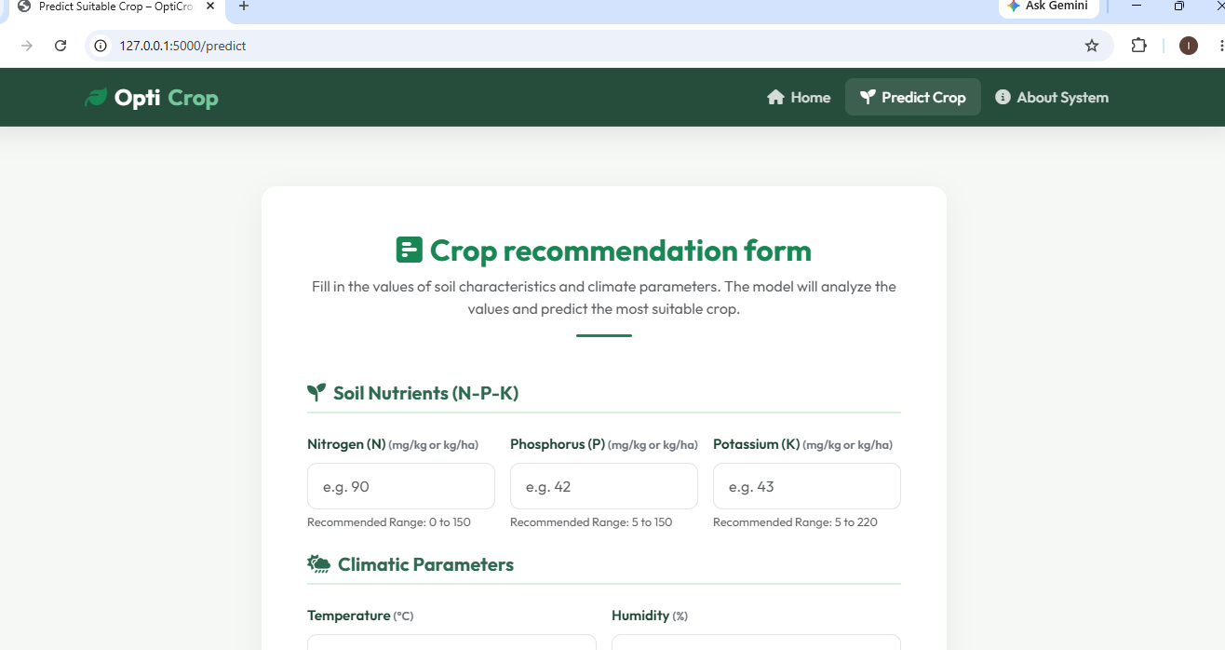

Step 2 — Install Required Libraries
Install the required libraries for machine learning and web development:
pip install pandas numpy scikit-learn flask pickle-mixin

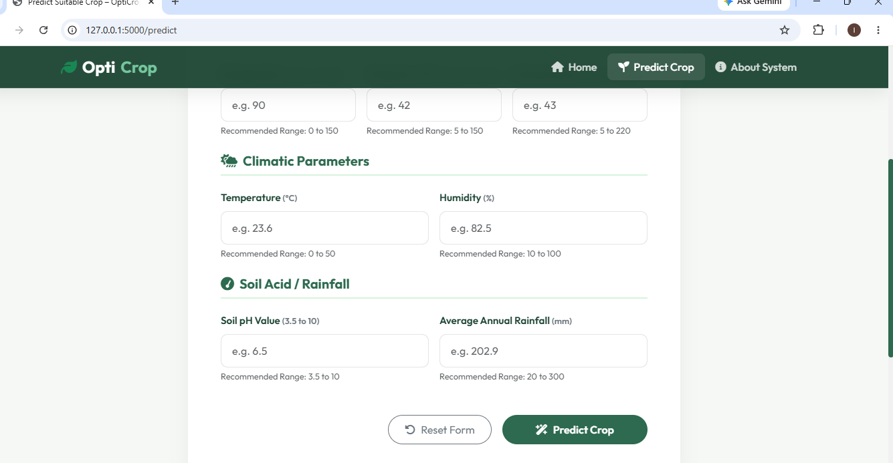

Step 3 — Load and Prepare the Dataset
Load the dataset and separate features from labels.
import pandas as pd

data = pd.read_csv("dataset/crop_recommendation.csv")

X = data.drop("label", axis=1)
y = data["label"]
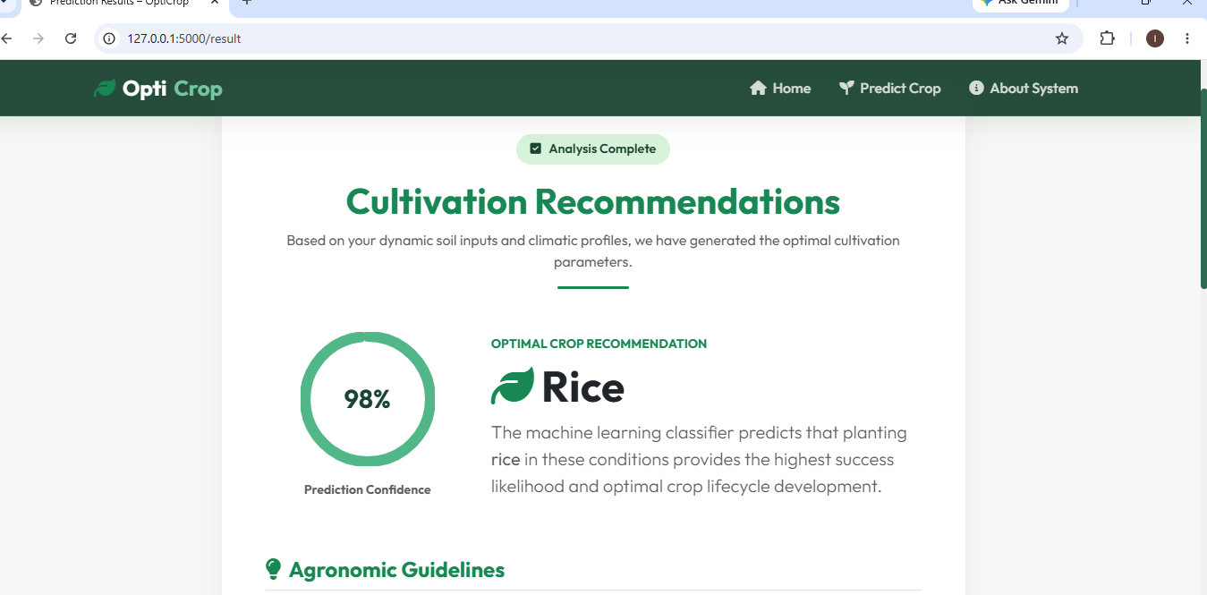

Step 4 — Train the Machine Learning Model
Train a Random Forest Classifier for crop recommendation.
from sklearn.ensemble import RandomForestClassifier

model = RandomForestClassifier(
n_estimators=100,
random_state=42
)

model.fit(X, y)

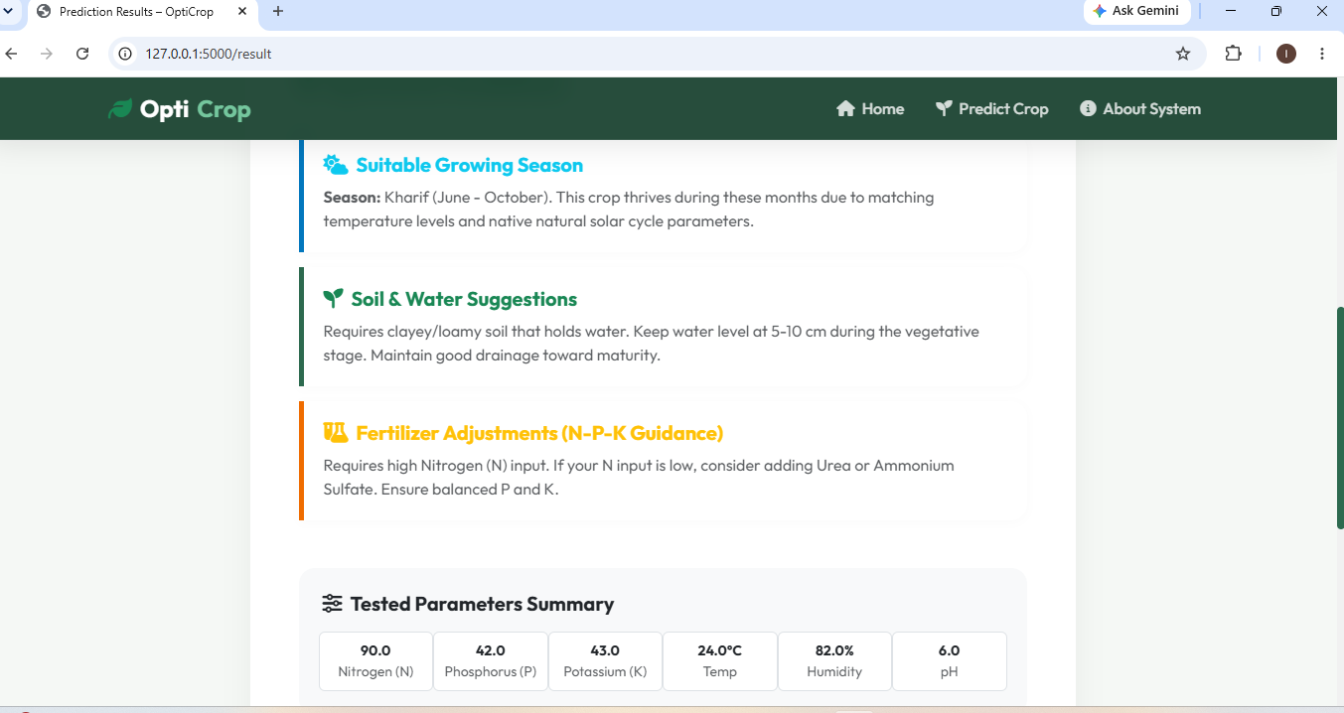

Activity 1.2: Research and Select the Appropriate Machine Learning Model
The following aspects were researched to select the most suitable machine learning model for the OptiCrop crop recommendation system:
• Understand the Project Requirements
Review the objectives of the OptiCrop application, focusing on recommending the most suitable crop based on soil nutrients and environmental parameters such as Nitrogen (N), Phosphorus (P), Potassium (K), Temperature, Humidity, pH Value, and Rainfall.
• Explore Various Machine Learning Algorithms
Study different machine learning algorithms suitable for classification tasks, including:
- Decision Tree Classifier
- Random Forest Classifier
- Support Vector Machine (SVM)
- K-Nearest Neighbors (KNN)
- Logistic Regression
Evaluate their suitability for agricultural prediction systems.
• Evaluate Model Performance
Compare the algorithms based on:
- Prediction Accuracy
- Training Time
- Prediction Speed
- Reliability
- Scalability
- Ability to handle agricultural datasets
• Select the Optimal Model
Choose the Random Forest Classifier because of its high accuracy, robustness, and ability to handle multiple agricultural features effectively.
Model Configuration:
- Algorithm: Random Forest Classifier
- Number of Trees (n_estimators): 100
- Random State: 42
- Output: Recommended Crop

Activity 1.3: Define the Architecture of the Application
• Draft an Architectural Diagram
Create a visual representation of the OptiCrop system architecture consisting of:
- Frontend (HTML, CSS, Bootstrap)
- Flask Backend
- Machine Learning Model
- Crop Recommendation Dataset
- Prediction Result Interface
[Insert Architecture Diagram Here]
User Input → Flask Application → Machine Learning Model → Crop Recommendation

• Detail Frontend Functionality
The frontend provides an interactive interface where users can:
- Enter Nitrogen (N) value
- Enter Phosphorus (P) value
- Enter Potassium (K) value
- Enter Temperature
- Enter Humidity
- Enter pH Value
- Enter Rainfall
- Submit data for crop prediction
The frontend validates basic input and displays prediction results in a user-friendly format.

Activity 1.4: Set Up the Development Environment
• Install Python and Pip
Ensure Python 3.8 or higher is installed on your system along with pip for package management.
Verify the installation using:
python --version
pip --version
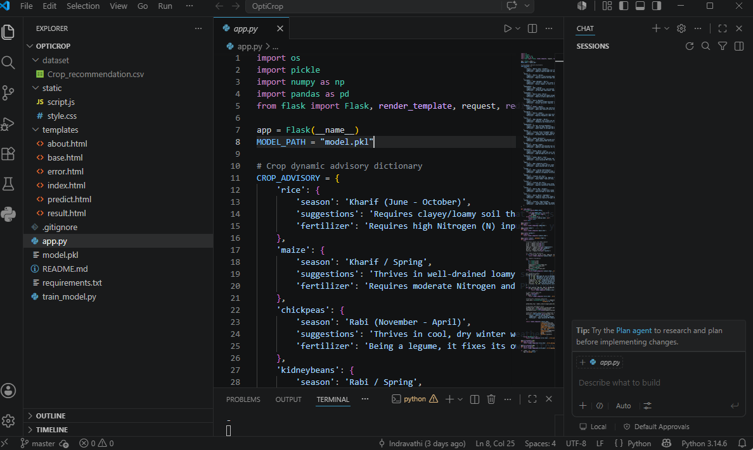

• Create a Virtual Environment
Create and activate a virtual environment to isolate project dependencies.
python -m venv myenv
Activate the environment:
Windows
myenv\Scripts\activate
Linux/macOS
source myenv/bin/activate

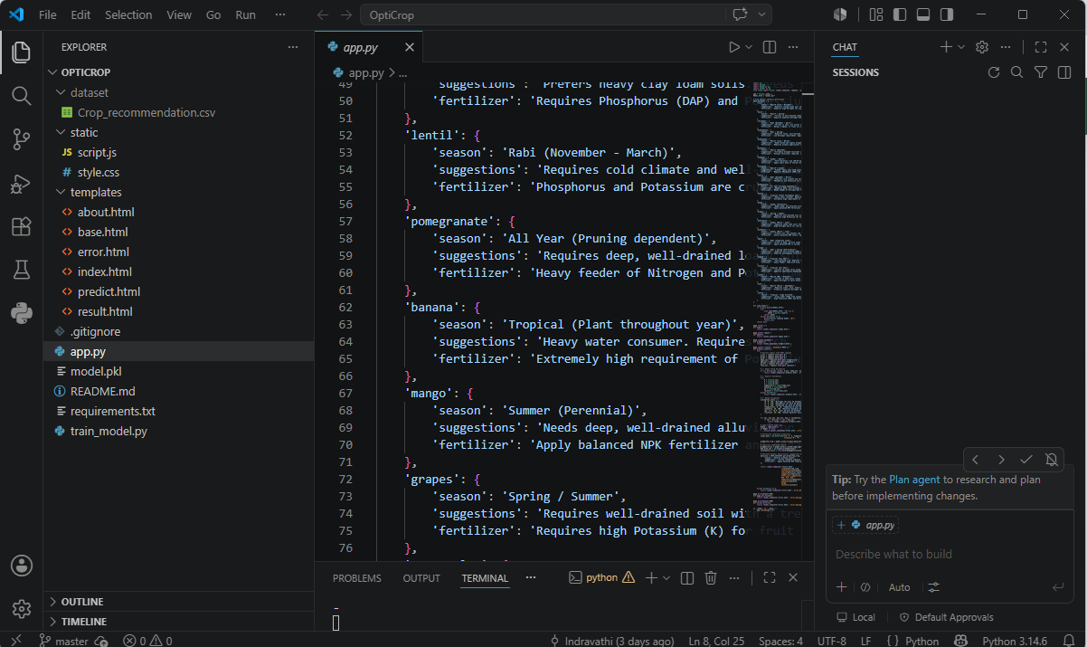

• Install Flask
Install Flask for developing the web application backend.
(myenv) D:\OptiCrop> pip install Flask==3.0.3
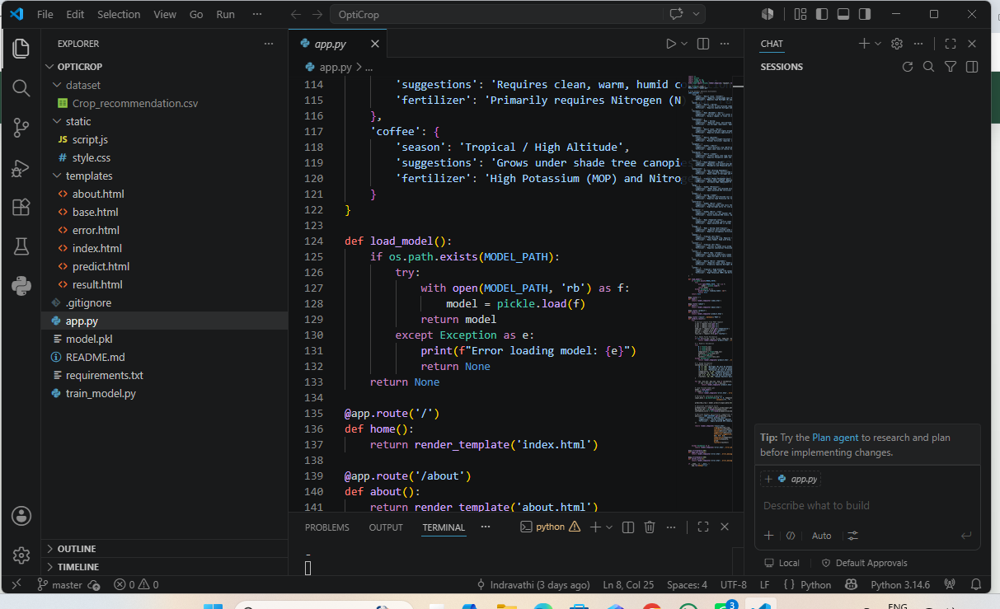

• Install Machine Learning Libraries
Install the required libraries for data processing and crop prediction.
(myenv) D:\OptiCrop> pip install pandas numpy scikit-learn

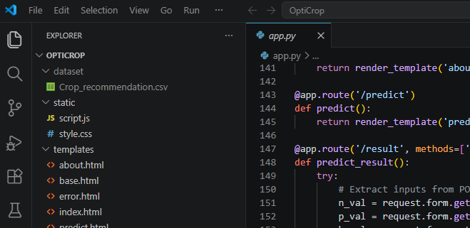

• Install Additional Dependencies
Install libraries required for model storage and project execution.
(myenv) D:\OptiCrop> pip install pickle-mixin
Create a requirements file:
pip freeze > requirements.txt

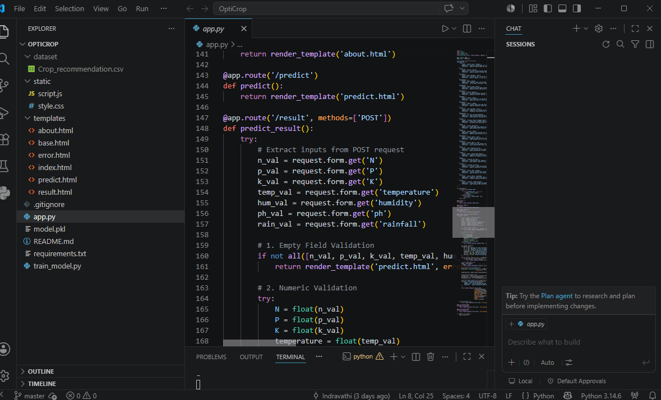
• Configure Project Files
Store the trained machine learning model in the project root directory.
model.pkl
The Flask application loads the model automatically during startup:
import pickle

model = pickle.load(open("model.pkl", "rb"))

• Configure Dataset Storage
Store the agricultural dataset inside the dataset folder.
dataset/
└── crop_recommendation.csv

• Set Up Application Structure
Create the project directory structure as follows:
OptiCrop/
│
├── app.py
├── model.pkl
├── train_model.py
├── requirements.txt
│
├── dataset/
│ └── crop_recommendation.csv
│
├── static/
│ ├── style.css
│ └── script.js
│
└── templates/
├── base.html
├── index.html
├── about.html
├── predict.html
├── result.html
└── error.html

• Run the Application
Start the Flask application using:
python app.py
Expected Output:
* Running on http://127.0.0.1:5000

Expected Outcome
After completing this activity:
- Python environment is configured successfully.
- Required libraries are installed.
- Dataset is stored correctly.
- Machine learning model is integrated.
- Flask application structure is organized.
- OptiCrop is ready for crop prediction and web deployment.

Milestone 2: Core Functionalities Development
Activity 2.1: Develop Core Crop Recommendation Features
Implement the core functionalities of the OptiCrop system to provide intelligent crop recommendations based on soil and environmental conditions.
• Crop Recommendation Engine
Develop a machine learning-based prediction engine that recommends the most suitable crop using the following inputs:
- Nitrogen (N)
- Phosphorus (P)
- Potassium (K)
- Temperature
- Humidity
- pH Value
- Rainfall
The system analyzes these parameters and predicts the most appropriate crop for cultivation.
• Input Validation Module
Implement input validation to ensure:
- All fields are entered correctly.
- Numerical values are within acceptable ranges.
- Empty or invalid inputs are rejected.
- User-friendly error messages are displayed.
• Prediction Result Module
Generate prediction results instantly after user submission.
The result page displays:
- Recommended Crop Name
- Input Parameters Used
- Prediction Status
- Recommendation Message
• User-Friendly Interface
Provide a responsive interface where farmers can easily enter agricultural parameters and receive recommendations without technical knowledge.

Activity 2.2: Implement the Flask Backend
• Define Routes in Flask
Configure Flask routes in app.py for navigation and crop prediction.
Example routes:
@app.route('/')
def home():
return render_template('index.html')

@app.route('/predict', methods=['POST'])
def predict():
pass

• Process User Input
Create an input form in predict.html that allows users to enter agricultural parameters.
Input Fields:
- Nitrogen (N)
- Phosphorus (P)
- Potassium (K)
- Temperature
- Humidity
- pH Value
- Rainfall
Use Flask's request.form to retrieve user input.
N = float(request.form['nitrogen'])
P = float(request.form['phosphorus'])
K = float(request.form['potassium'])
temperature = float(request.form['temperature'])
humidity = float(request.form['humidity'])
ph = float(request.form['ph'])
rainfall = float(request.form['rainfall'])
• Validate User Input
Verify:
- No field is left empty.
- Values are numeric.
- Values fall within valid agricultural ranges.
Display error messages if validation fails.

• Integrate Machine Learning Model
Load the trained model inside the Flask application.
import pickle

model = pickle.load(open('model.pkl', 'rb'))

• Generate Crop Prediction
Pass user inputs to the trained machine learning model.
prediction = model.predict(
[[N, P, K, temperature, humidity, ph, rainfall]]
)
The model returns the recommended crop.
Example Output:
Recommended Crop: Rice

• Display Results to Users
Send prediction results back to the frontend.
return render_template(
'result.html',
prediction=prediction[0]
)
The result page displays:
- Recommended Crop
- Success Message
- User Inputs

Backend Workflow
- User enters agricultural parameters.
- Flask receives form data.
- Input validation is performed.
- Trained model is loaded.
- Machine learning model generates prediction.
- Predicted crop is returned.
- Result page displays recommendation.
User Input → Flask Backend → Data Validation → ML Model → Crop Prediction → Result Page

Expected Outcome
After completing Milestone 2:
- Crop recommendation functionality is implemented.
- Flask backend processes user requests successfully.
- Input validation ensures reliable predictions.
- Machine learning model is integrated with the web application.
- Users receive accurate crop recommendations through a simple web interface.
This milestone transforms OptiCrop from a trained machine learning model into a fully functional intelligent crop recommendation web application.

Milestone 3: App.py Development
Milestone 3 focuses on creating and refining the core logic of the app.py file, which serves as the backbone of the OptiCrop application. In this milestone, the Flask routes, machine learning model integration, input validation, and prediction functionality are implemented and tested to ensure reliable crop recommendations.

Activity 3.1: Writing the Main Application Logic in app.py
Define the Core Routes in app.py
Establish routes for OptiCrop's primary functionalities.
• Home Route
The home route renders the main user interface where farmers can enter agricultural parameters.
@app.route('/')
def home():
return render_template('index.html')
• Prediction Route
The prediction route accepts user inputs, processes the data, invokes the machine learning model, and returns the recommended crop.
@app.route('/predict', methods=['POST'])
def predict():
pass

Set Up Route Handlers for Crop Prediction
• Process User Inputs
The application reads the following inputs submitted through the form:
- Nitrogen (N)
- Phosphorus (P)
- Potassium (K)
- Temperature
- Humidity
- pH Value
- Rainfall
Example:
N = float(request.form['nitrogen'])
P = float(request.form['phosphorus'])
K = float(request.form['potassium'])
temperature = float(request.form['temperature'])
humidity = float(request.form['humidity'])
ph = float(request.form['ph'])
rainfall = float(request.form['rainfall'])
• Input Validation
Validate that:
- No field is empty.
- Values are numeric.
- Values fall within acceptable agricultural ranges.
If invalid input is detected, display an error message.
if not all([N, P, K, temperature, humidity, ph, rainfall]):
return render_template('error.html')

Define Prediction Helpers
• Agricultural Features
The model accepts the following feature vector:
features = [[
N,
P,
K,
temperature,
humidity,
ph,
rainfall
]]
• Model Loading Function
Load the trained Random Forest model.
import pickle

model = pickle.load(
open('model.pkl', 'rb')
)

Integrate Machine Learning Predictions
• Generate Crop Recommendation
Pass the agricultural features to the trained model.
prediction = model.predict(features)
• Extract Prediction Result
Retrieve the recommended crop.
recommended_crop = prediction[0]
Example Output:
Recommended Crop: Rice

Validate Prediction Results
Ensure that:
- Prediction is successfully generated.
- Crop name is returned correctly.
- Result is displayed without errors.
Example:
if recommended_crop:
print("Prediction Successful")

Return Results to Frontend
Send the prediction result to the result page.
return render_template(
'result.html',
crop=recommended_crop
)
The result page displays:
- Recommended Crop
- Input Parameters
- Success Message

Application Workflow
Home Route
/ → renders index.html
Prediction Route
/predict (POST)
Workflow Diagram
User Input
↓
Flask Backend
↓
Input Validation
↓
Feature Preparation
↓
Random Forest Model
↓
Crop Prediction
↓
Result Page

Expected Outcome
After completing Milestone 3:
- Flask routes are fully implemented.
- User inputs are validated successfully.
- Machine learning model is integrated with the backend.
- Crop predictions are generated accurately.
- Results are displayed through a user-friendly interface.
- OptiCrop functions as a complete crop recommendation system capable of assisting farmers in selecting suitable crops based on soil and environmental conditions.
This milestone establishes the complete application logic and connects the frontend, backend, and machine learning model into a fully operational intelligent agricultural recommendation system.

Milestone 4: Frontend Development
Milestone 4 focuses on developing a user-friendly and visually appealing interface for the OptiCrop application. This involves designing a modern, responsive web interface that allows farmers and agricultural professionals to enter soil and environmental parameters easily and receive crop recommendations dynamically. The frontend should provide a clean user experience, responsive layouts, and real-time result visualization.

Activity 4.1: Designing and Developing the User Interface
Set Up the Base HTML Structure
- Develop the main HTML pages (index.html, predict.html, and result.html) to provide a seamless user experience.
- Create a navigation header containing:
  - OptiCrop logo
  - Project title
  - Navigation links (Home, About, Crop Prediction)
- Design an input section where users can enter:
  - Nitrogen (N)
  - Phosphorous (P)
  - Potassium (K)
  - Temperature
  - Humidity
  - pH Value
  - Rainfall
- Create a results section to display:
  - Recommended crop
  - Suitability information
  - Agricultural insights
- Use semantic HTML elements such as:
  - <header>
  - <nav>
  - <main>
  - <section>
  - <article>
  - <footer>
- Integrate:
  - Font Awesome icons for agriculture-related visuals
  - Google Fonts (Inter/Poppins) for modern typography

Design a Responsive Layout Using CSS
- Create a CSS stylesheet (static/css/style.css) implementing a modern agriculture-inspired design with glassmorphism effects and subtle background animations.
- Use gradient backgrounds with nature-inspired colors:
  - Green
  - Blue
  - Earth tones
- Add animated background elements to create visual depth and enhance user engagement.
- Use Flexbox and CSS Grid layouts to organize content efficiently.
- Structure the prediction interface into two main sections:
  - Left Panel → User Input Form
  - Right Panel → Prediction Results
- Implement media queries to ensure compatibility across:
  - Desktop devices
  - Tablets
  - Mobile phones

Create Separate UI Components for Prediction Results
Crop Recommendation Card
- Display the predicted crop inside a highlighted recommendation card.
- Include:
  - Crop name
  - Crop icon/image
  - Recommendation confidence (optional)
- Add a visually appealing success animation when results are displayed.
Soil Information Card
- Show the user-entered soil parameters in a dedicated glassmorphism card.
- Present values in a structured format for easy review.
Agricultural Insights Card
- Display farming recommendations such as:
  - Suitable growing conditions
  - Water requirements
  - Soil suitability information
  - General cultivation tips
- Include relevant agriculture icons for better visualization.

Activity 4.2: Creating Dynamic Content Rendering with JavaScript
Handle Form Submission Asynchronously
- Attach a submit event listener to the crop prediction form.
- Prevent default form submission behavior.
- Send input values asynchronously to the Flask backend (/predict) using the Fetch API and JSON format.
- During prediction:
  - Disable the Predict Crop button.
  - Show an animated loader.
  - Display a "Predicting Crop..." message.

Render Prediction Results Dynamically
- Implement a renderResults(data) function in main.js.
- Dynamically create and inject:
  - Crop Recommendation Card
  - Soil Information Card
  - Agricultural Insights Card
- Display the predicted crop returned by the machine learning model.
- Apply smooth animations when rendering results.
- Automatically scroll to the results section using:
resultsSection.scrollIntoView({
behavior: "smooth"
});

Restore UI State After Prediction
- In the finally block of the asynchronous request:
  - Re-enable the Predict Crop button.
  - Remove the loading animation.
  - Restore the original button text and icon.
  - Ensure proper error handling if prediction fails.
- Display user-friendly error messages when invalid inputs or server issues occur.

Expected Outcome
By the end of Milestone 4, the OptiCrop application will feature:
- A modern and responsive agricultural dashboard.
- Interactive soil parameter input forms.
- Dynamic crop prediction display.
- Real-time communication with the Flask backend.
- Mobile-friendly and accessible user interface.
- Enhanced user experience through animations, loaders, and smooth result rendering.

Milestone 5: Deployment
In Milestone 5, the focus is on deploying the OptiCrop – Smart Agricultural Production Optimization System first locally to verify correct operation and then publicly via Ngrok to make the application accessible through a secure web URL. This involves configuring the Flask environment, managing dependencies, loading the trained machine learning model, and launching the application for real-world use.

Activity 5.1: Preparing the Application for Local Deployment
Set Up a Virtual Environment
- Open a New Terminal.
- Open Command Prompt.
- Navigate to the OptiCrop project directory.
- Create and activate a virtual environment:
python -m venv myenv
Activate Virtual Environment
Windows
myenv\Scripts\activate
Linux / macOS
source myenv/bin/activate
- Install all required dependencies from requirements.txt:
pip install -r requirements.txt

Configure Application Settings
- Ensure all required project files are available:
OptiCrop/
│
├── app.py
├── model.pkl
├── requirements.txt
├── static/
├── templates/
└── dataset/
- Verify that the trained machine learning model (model.pkl) is located in the project root directory.
- Confirm that Flask loads the model successfully during application startup.

Activity 5.2: Local Testing and Verification
Start the Flask Development Server
Run the application locally using:
(myenv) D:\projects\OptiCrop> python app.py
Once the server starts successfully, open a browser and navigate to:
http://127.0.0.1:5000

Test Application Functionality
Verify the following features:
Home Page
- Application loads successfully.
- Navigation menu functions correctly.
- Responsive design works on different screen sizes.
Crop Prediction Page
Enter sample agricultural values:
- Nitrogen (N)
- Phosphorous (P)
- Potassium (K)
- Temperature
- Humidity
- pH
- Rainfall
Click Predict Crop and verify that:
- Data is submitted successfully.
- The machine learning model processes the input.
- The predicted crop is displayed correctly.
Result Page
Verify that the system displays:
- Recommended crop name.
- Input parameter summary.
- Agricultural recommendations.
- Crop suitability information.
Error Handling
Test invalid inputs such as:
- Empty fields
- Negative values
- Non-numeric values
Ensure appropriate validation messages are displayed.

Activity 5.3: Public Deployment via Ngrok
Ngrok creates a secure tunnel from a public URL to the local Flask server, allowing farmers, researchers, and agricultural professionals to access OptiCrop from anywhere without requiring cloud hosting.

Install Ngrok and Pyngrok
Install the Python wrapper:
pip install pyngrok
Download and install the Ngrok client from:
Ngrok Download Page
For Windows:
- Select the Microsoft Store Installer or Windows executable.
- Complete the installation process.

Configure Your Ngrok Authtoken
- Create an account on:
Ngrok Official Website
- Copy your authtoken from the Ngrok Dashboard.
- Add the token inside run_public.py:
from pyngrok import ngrok

ngrok.set_auth_token("YOUR_NGROK_AUTHTOKEN")
Replace the placeholder with your personal Ngrok authentication token.

Run the Public Deployment Script
Instead of launching app.py directly, run:
python run_public.py
The script automatically:
- Starts the Flask server.
- Creates an Ngrok tunnel.
- Generates a public URL.
Example:
=====================================================
OPTICROP PUBLIC WEBSITE IS LIVE!
URL: https://xxxx-xx-xx-xxx-xx.ngrok-free.app
=====================================================
Users can access the OptiCrop application through this URL without installing any software.

Important Notes
- Set:
debug=False
in run_public.py to avoid Flask reloader conflicts with Ngrok.
- On the free Ngrok plan:
  - Public URLs change whenever the tunnel restarts.
  - Sessions expire after periods of inactivity.
- To obtain a permanent URL:
  - Upgrade to a paid Ngrok plan.
  - Configure a reserved domain.

Exploring the Website's Web Pages
Home Page
Description
The Home Page serves as the landing page for OptiCrop and introduces users to the Smart Agricultural Production Optimization System.
Features include:
- Attractive agriculture-themed design.
- Project overview.
- Navigation menu.
- Call-to-action button directing users to crop prediction.

About Page
Description
The About Page provides detailed information about:
- Project objectives.
- Machine Learning algorithms used.
- Dataset features.
- Technology stack.
- Benefits of smart crop recommendation systems.
It helps users understand how OptiCrop improves agricultural decision-making.

Crop Prediction Page
Description
The Crop Prediction Page contains a user-friendly input form where users provide:
- Nitrogen (N)
- Phosphorous (P)
- Potassium (K)
- Temperature
- Humidity
- pH
- Rainfall
The page validates inputs and submits them to the machine learning model for prediction.

Results Page
Description
The Results Page displays prediction outcomes in a visually appealing format.
It includes:
Crop Recommendation Card
- Predicted crop name.
- Crop image/icon.
- Recommendation status.
Soil Parameter Summary Card
- User-entered environmental values.
- Structured parameter display.
Agricultural Insights Card
- Suitable growing conditions.
- Water requirements.
- Soil recommendations.
- Crop cultivation tips.
The page automatically scrolls to results after prediction and provides a smooth user experience.



Conclusion

OptiCrop is an intelligent agricultural recommendation platform developed using Flask, Machine Learning, HTML, CSS, JavaScript, and Python. The system analyzes key environmental and soil parameters such as Nitrogen, Phosphorous, Potassium, temperature, humidity, pH, and rainfall to recommend the most suitable crop for cultivation.
The project demonstrates how data-driven decision-making can support modern agriculture by helping farmers select crops that maximize productivity and resource efficiency. Through a responsive web interface, real-time predictions, and deployment using Ngrok, OptiCrop provides an accessible solution for crop recommendation and agricultural planning.
Looking ahead, OptiCrop can be expanded with advanced features such as weather API integration, fertilizer recommendation systems, disease prediction modules, yield forecasting, multilingual support, and cloud-based deployment. By continuously improving the machine learning models and user experience, OptiCrop has the potential to evolve into a comprehensive smart farming assistant that empowers farmers and promotes sustainable agricultural practices.

